FOR IMMEDIATE RELEASE
——————————————————————————————————————————————
Thrive: Queer voices, out loud.
A new work of theatre captures the untold stories of LGBTQIA+ Victorians, young and old.
——————————————————————————————————————
Presented by Black Apple Theatre

Thrive: Queer voices, out loud, has been created by Castlemaine-based company Black Apple Theatre, who have gathered true stories from the LGBTQIA+ community in Central Victoria and shaped them into a play, which will premiere in Melbourne from 24 - 28 January as part of Midsumma Westside.

“We’ve been working on Thrive for two years now,” says director Cheyney Caddy (she/they), “it’s been such a labour of love and I couldn’t be more excited to share this work with audiences. I think when you become a theatre-maker everyone starts with the idea that they want to change the world for the better, and then as you gain experience you learn how rare an opportunity that actually is; once in a lifetime, if you’re lucky. Thrive is my once in a lifetime. I know this work is going to make a difference.”

Thrive interweaves the real-life journeys of five LGBTQIA+ Victorians, three over 65+ and two 25 year olds, into a powerful piece of theatre that explores the way the generations are connected by love, humour, resilience and a fierce determination to create a more equitable future for their community.

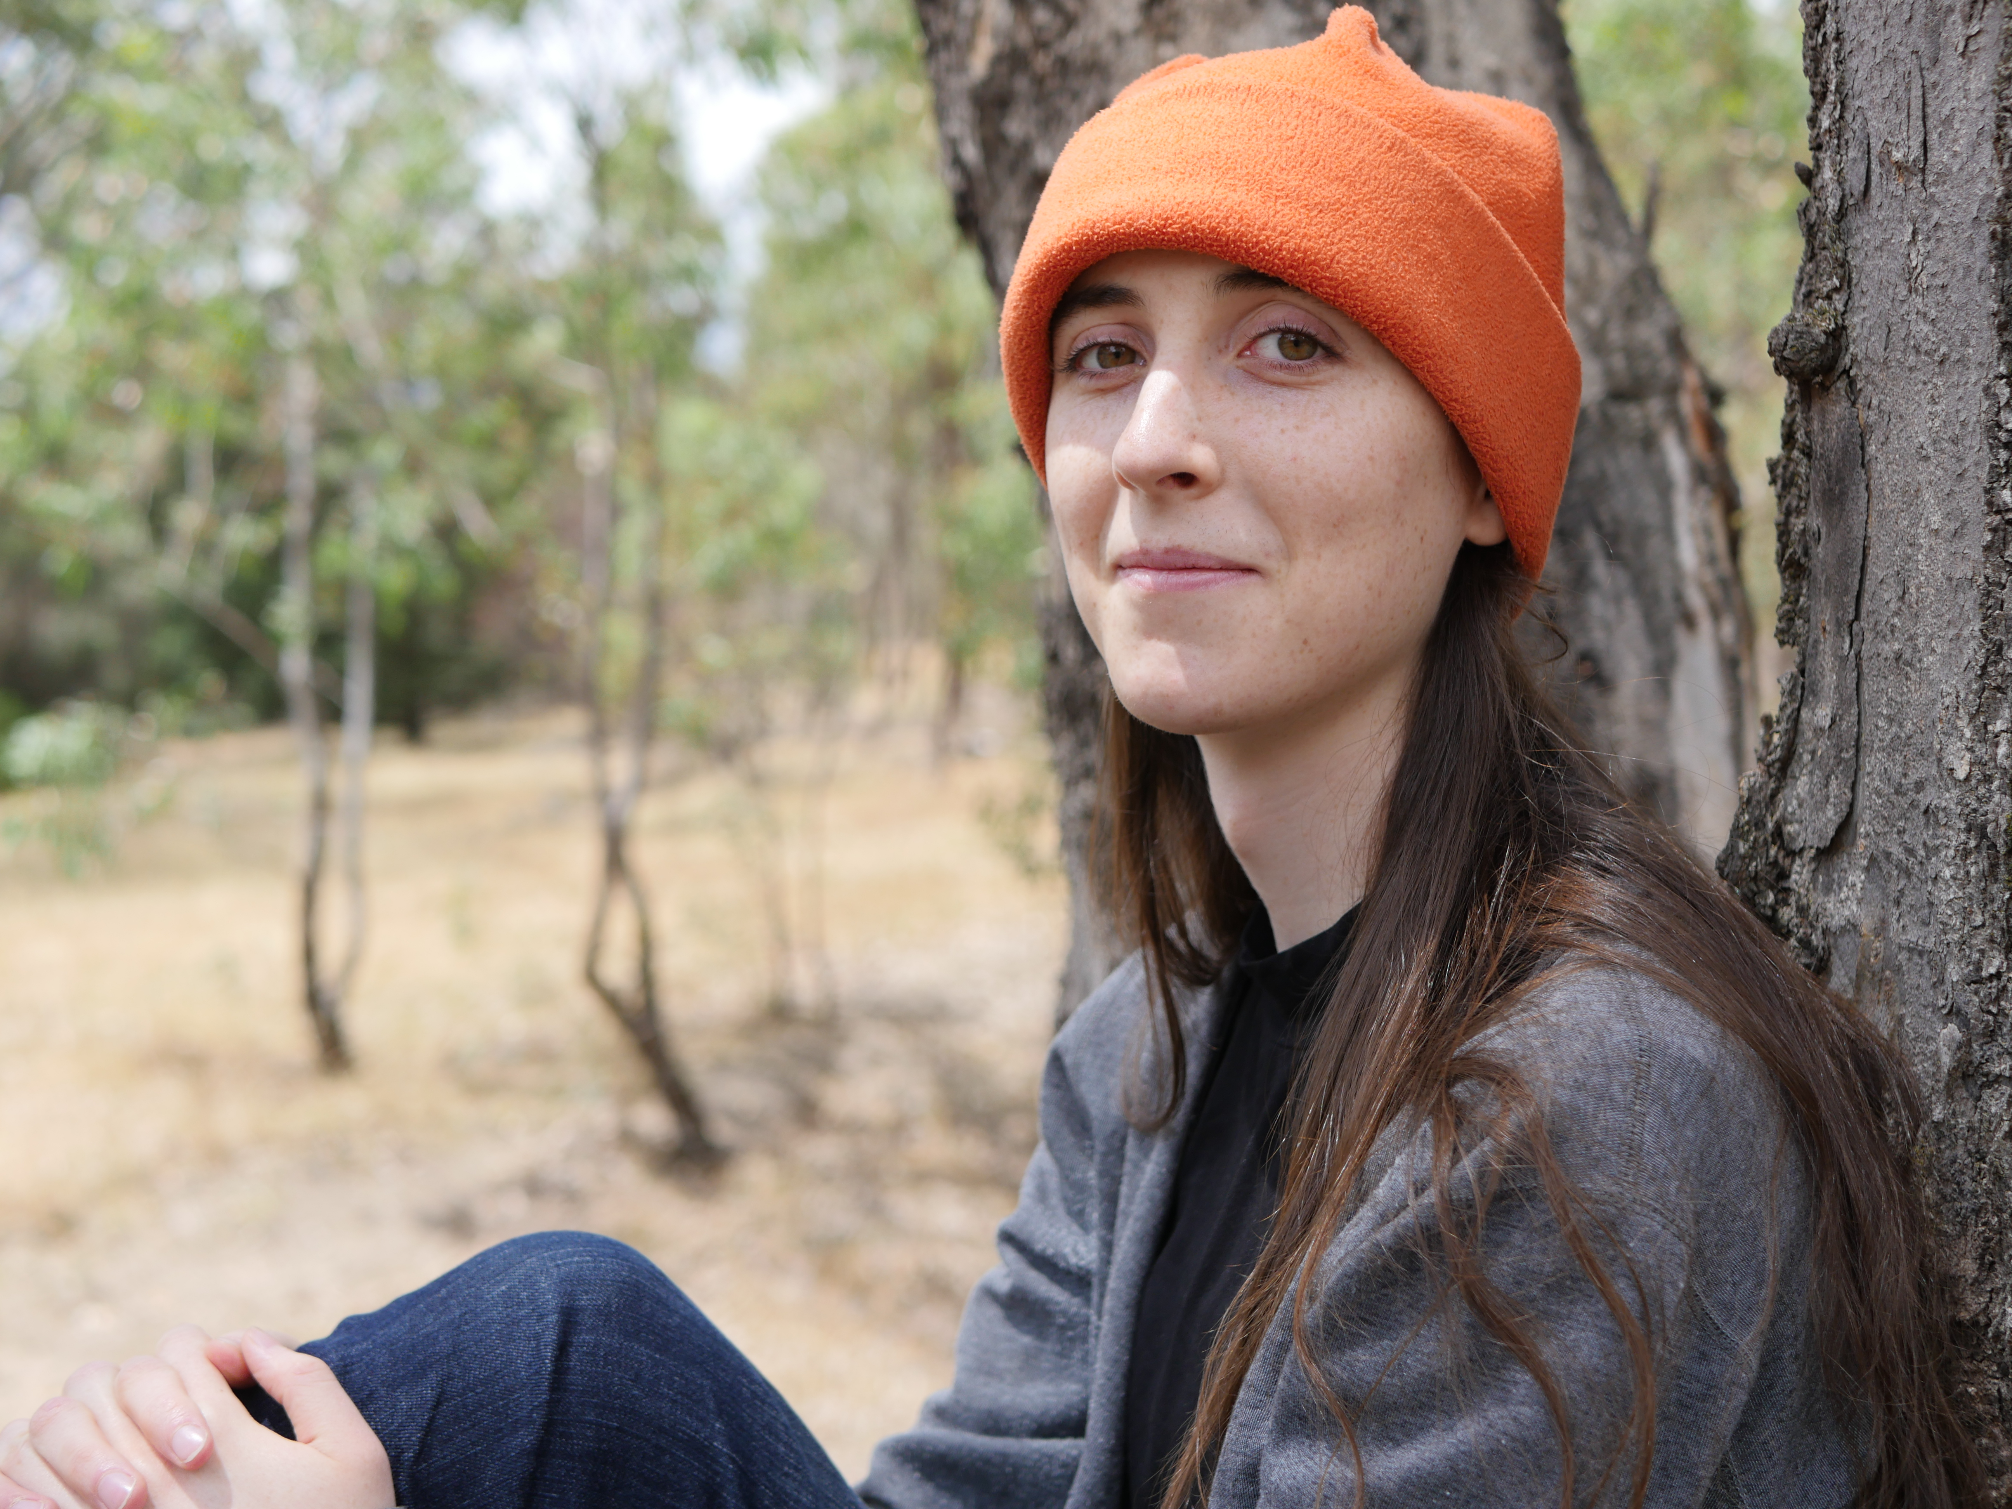
Described by its makers as a work made ‘for community, by community,’ all of the artists and performers working on Thrive identify as part of the LGBTQIA+ community, which gives them a unique connection into the stories they are telling.
Maldon local, Aspen Beilharz is the young performer who plays trans activist Julie Peters in Thrive. Photo credit: Ally Riches

Aspen Beilharz (she/they), is the young performer responsible for telling the story of Julie Peters; the real-life activist and trailblazer who became the first transgender person to run for parliament in Australia. “Rehearsing Thrive has been a wonderfully warm, joyful, energised experience,” Aspen says, “We’re having fun, but more than that, everyone is passionate about the work we’re doing. Having the chance to explore Julie’s story and bring it to the stage has been an honour.”

Equally, Julie (she/her), talks about the impact of having her story told in Thrive; “Thrive helped me reconnect with my Regional Victorian roots and learn the incredible sense of inclusion for gender, relationship and sexuality diverse individuals and communities in country Victoria today. When I was younger there was a sense amongst gender and sexuality diverse individuals that you needed the anonymity of the big city to feel safe being yourself.”

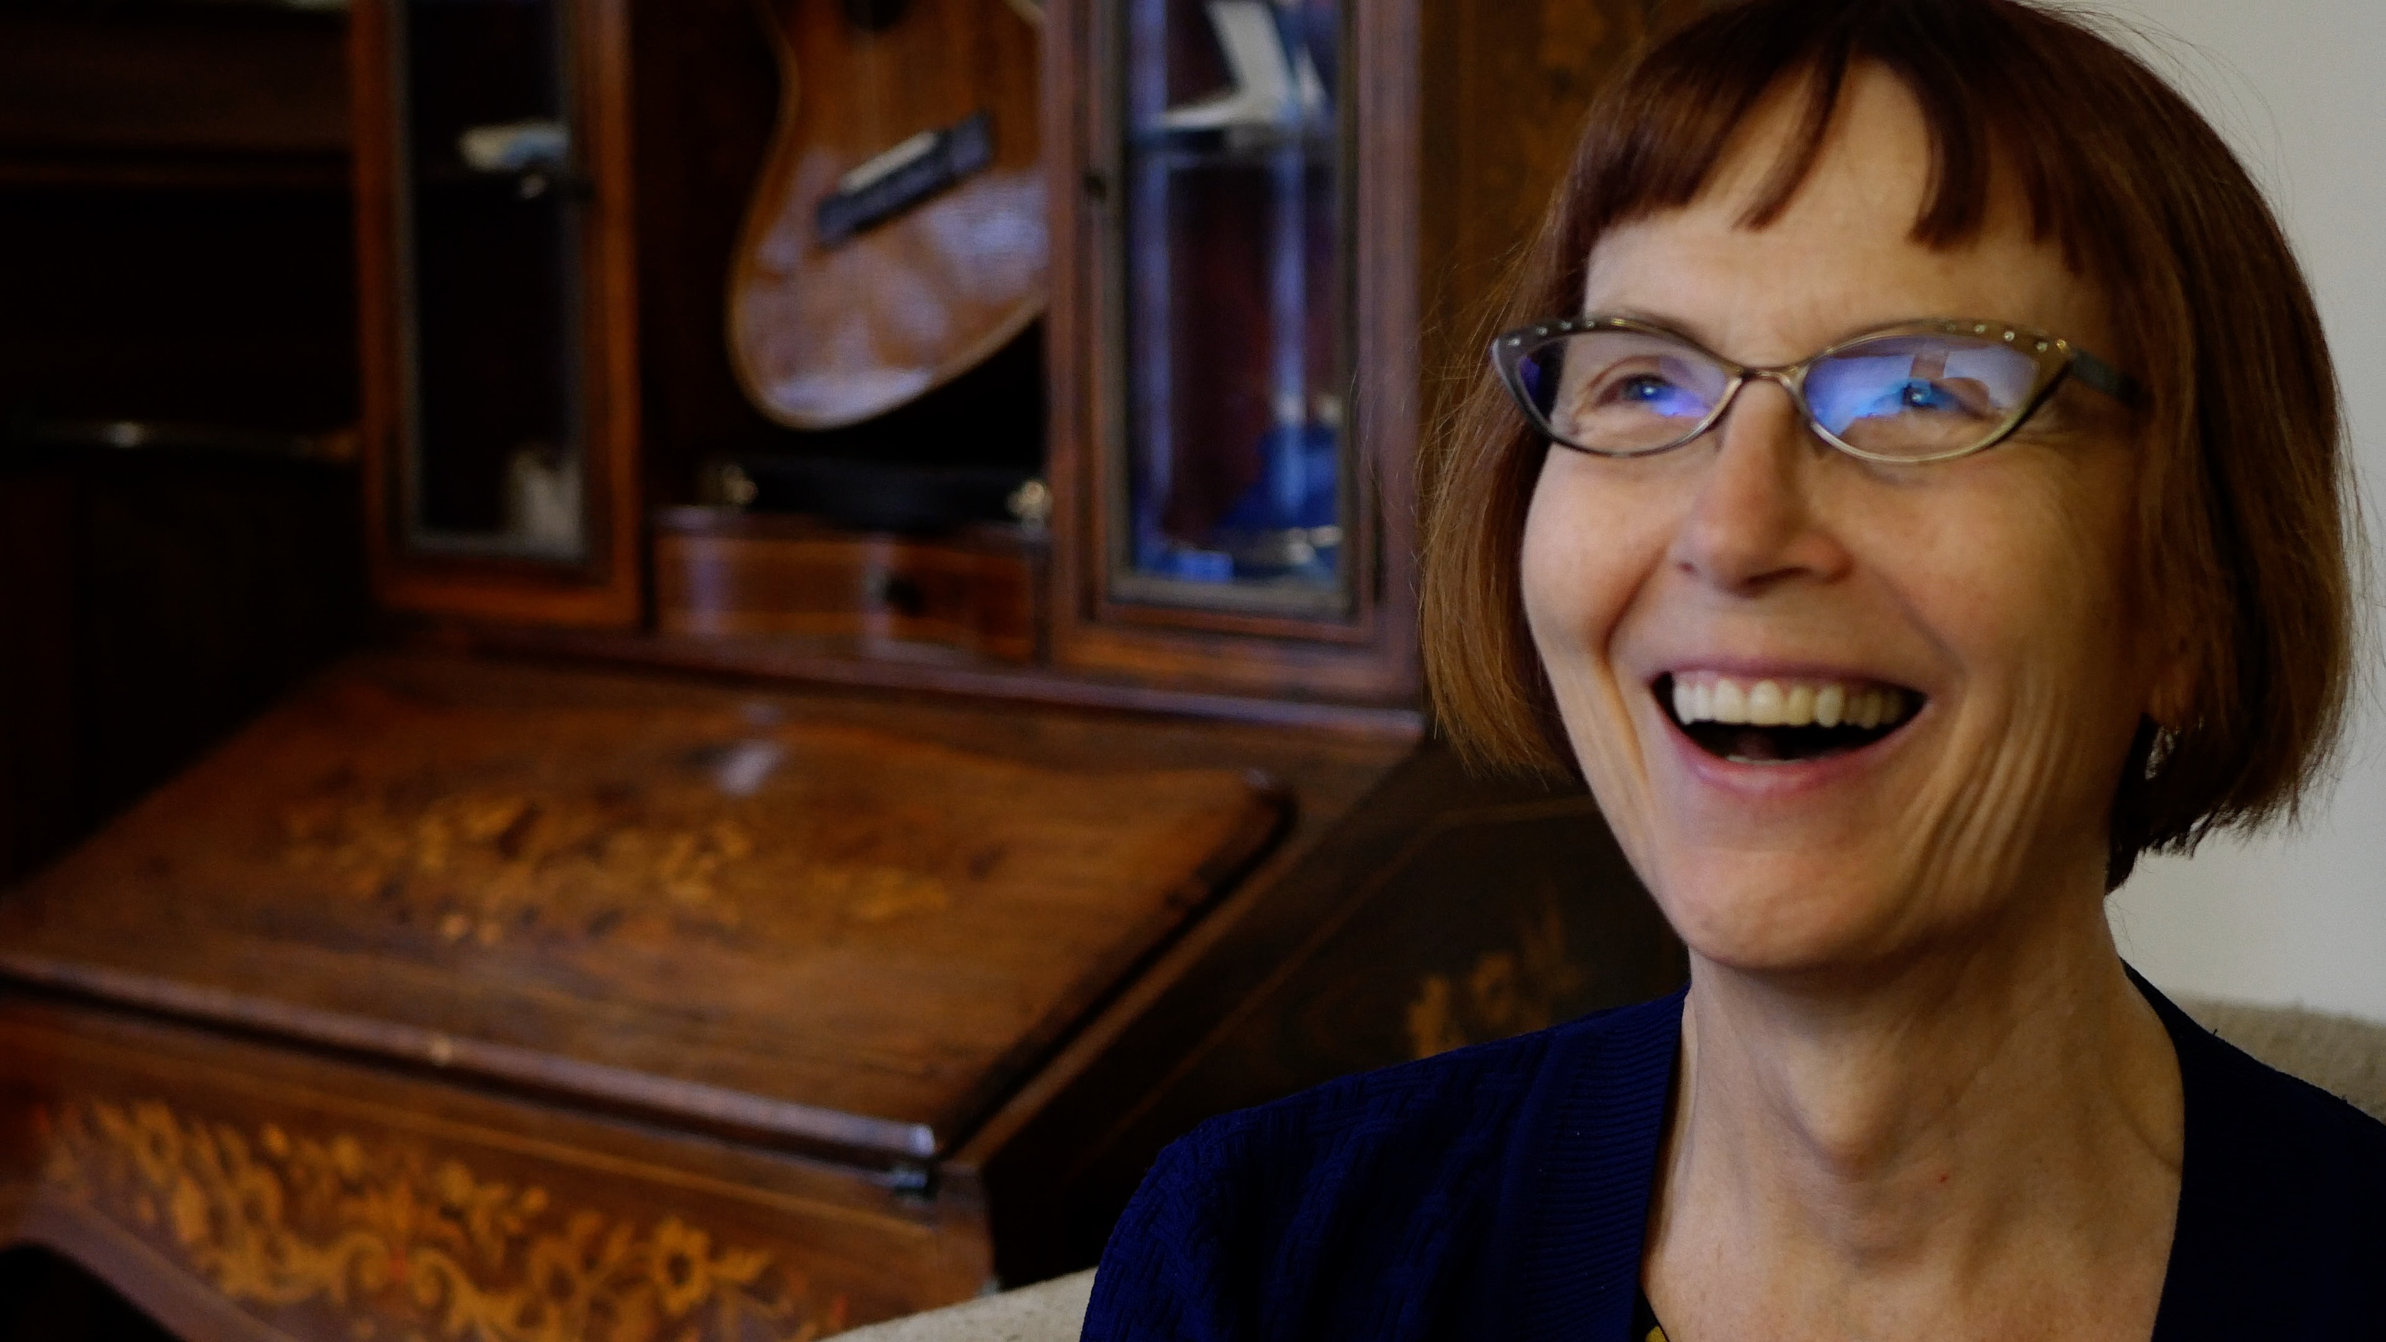
The idea that queerness is ‘something that happens in the city’ has lead to individuals feeling invisible in their regional communities, and the need for authentic representation to address this is a thread that runs through Thrive.
Julie Peters is one of the LGBTQIA+ trailblazers whose story is part of Thrive: Queer voices, out loud. Photo credit: Ally Riches

Young performer Issy Weiskopf (she/her) describes her motivation: “These are stories that need to be told. We need a history of the queer rural experience, as so many of these stories have historically been silenced.” What does Thrive have to offer audiences? “A true sense of community. It’s for the gays, by the gays!” Issy jokes, adding: “And it’s also pretty bloody awesome.”
Issy Weiskopf is one of the young and emerging LGBTQIA+ performers in Thrive: Queer voices out loud. Photo credit: Ally Riches.

Discussion panels with the cast and creative team will be run after each performance.

The Melbourne premiere of Thrive was made possible through the support of Maribyrnong City Council.

——————————————————————————————————————

24 - 28 January, 2023
7.30pm
Bluestone Church Arts Space, Footscray

Tickets: www.midsumma.org.au

www.blackappletheatre.com

MEDIA CONTACT:
Cheyney Caddy | 0411 982 712 | blackappletheatre@gmail.com

